SAMPLE EMAIL -- CUSTOMIZE AND SEND TO MEMBERS

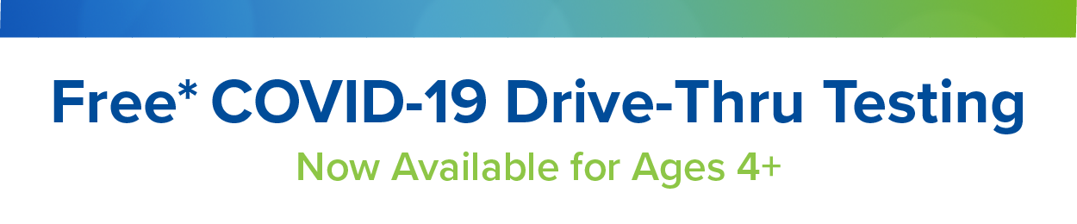

Subject Line: Free drive-thru COVID-19 testing at Rite Aid locations

Dear Member,
(CLIENT NAME) uses Elixir to manage your pharmacy benefits. As part of our ongoing efforts to help combat the COVID-19 pandemic, we and Elixir are pleased to offer you free drive-thru COVID-19 testing at Rite Aid locations.
- Testing is available for those aged four and older
- Appointments are required
- Results are typically available in 2 to 3 days

SCHEDULE AN APPOINTMENT

If you are near a Rite Aid location and would like to schedule an appointment for drive-thru COVID testing, please visit the appointment site today. See the attached flyer for more details.

Sincerely,
(CLIENT NAME)

